Database Connectivity with MS SQL Server

Create database and table in SQL Server

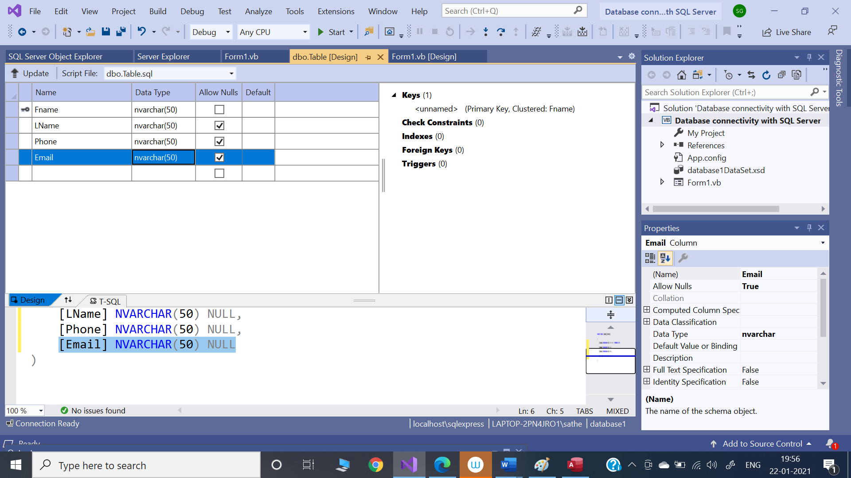

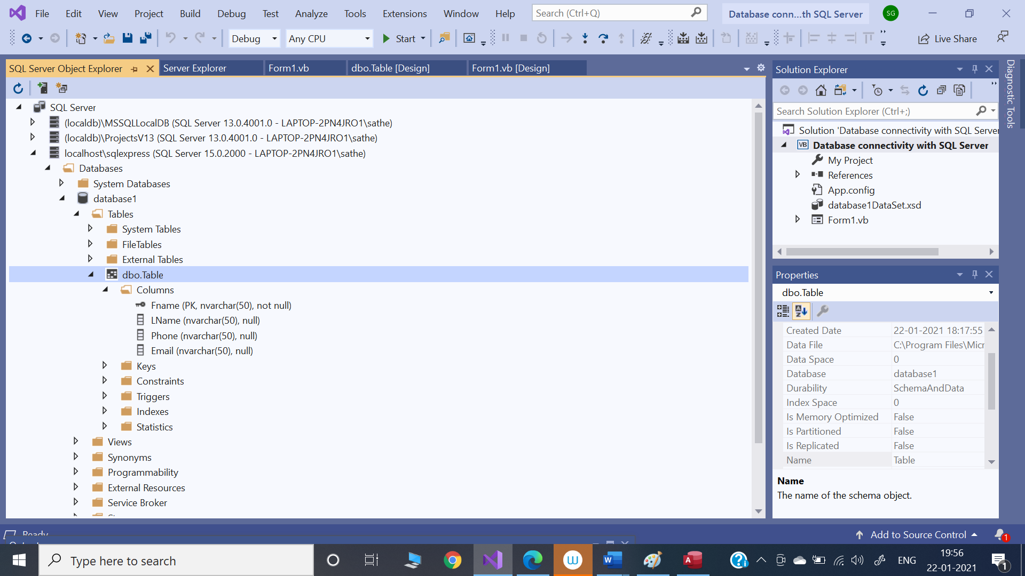

Design a page in Visual Studio

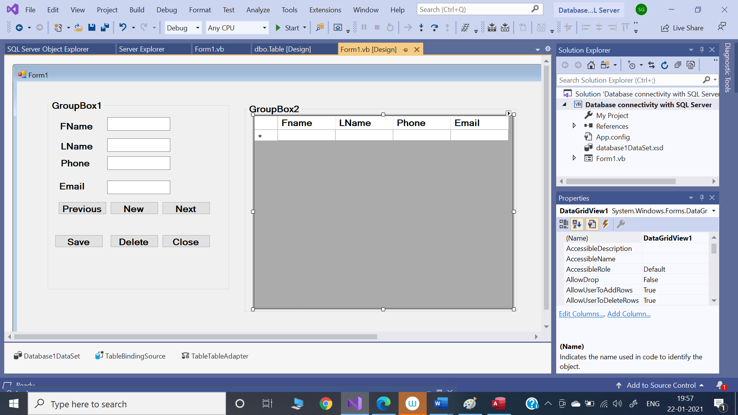

Program:

Public Class Form1

Private Sub Form1_Load(sender As Object, e As EventArgs) Handles MyBase.Load

'TODO: This line of code loads data into the 'Database1DataSet.Table' table. You can move, or remove it, as needed.

Me.TableTableAdapter.Fill(Me.Database1DataSet.Table)

End Sub

Private Sub Button1_Click(sender As Object, e As EventArgs) Handles Button1.Click

TableBindingSource.MovePrevious()

End Sub

Private Sub Button2_Click(sender As Object, e As EventArgs) Handles Button2.Click

TableBindingSource.AddNew()

End Sub

Private Sub Button3_Click(sender As Object, e As EventArgs) Handles Button3.Click

TableBindingSource.MoveNext()

End Sub

Private Sub Button4_Click(sender As Object, e As EventArgs) Handles Button4.Click

TableBindingSource.EndEdit()

TableTableAdapter.Update(Database1DataSet)

MessageBox.Show("Datasaved")

End Sub

Private Sub Button6_Click(sender As Object, e As EventArgs) Handles Button6.Click

Me.Close()

End Sub

Private Sub Button5_Click(sender As Object, e As EventArgs) Handles Button5.Click

TableBindingSource.RemoveCurrent()

End Sub

End Class

Output:

